Student Options
At some schools (secondary) students may select the subjects they wish to take using the Gateway’s student option module. This is usually done for GCSE or IB subject selection.
Students may login to submit the option form and then their parent online confirmation might be required which is depends on school’s requirement.

Submit Student Form

Student Login Gateway https://tg.esf.edu.hk
- You will see the Student Option link if applicable to your year level.

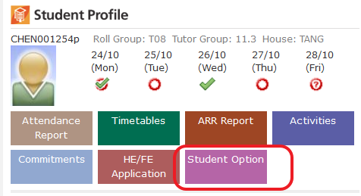
- Read the instructions on the form carefully …
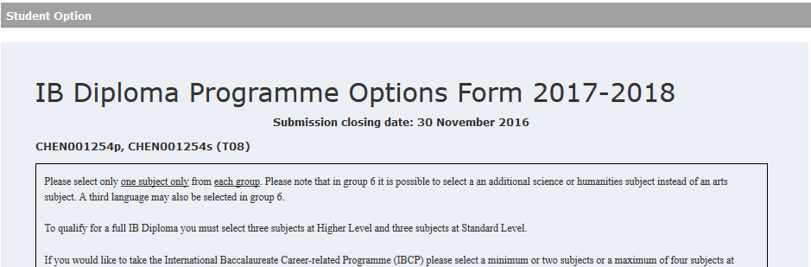
… …
There might be further file attachment for reference at the bottom of the text box.

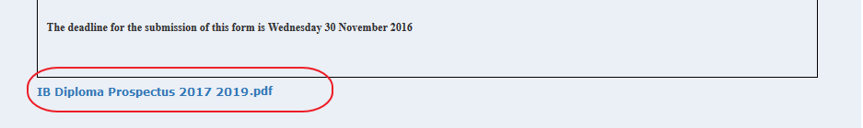

- Student may select the subjects from different Groups.
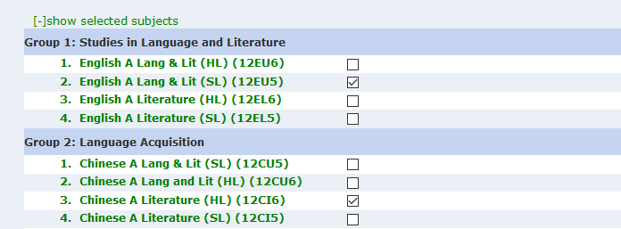
- You may input your justifications on your options
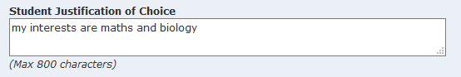
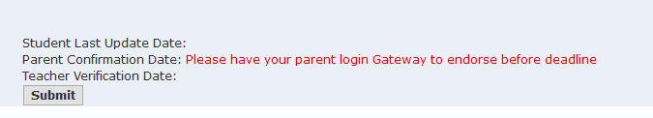

- Click Submit button to submit your form, it will popup a confirmation box. click confirm to submit.
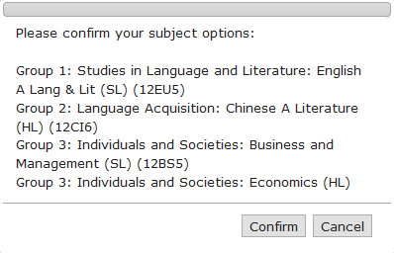

After sucessfully submission, you will see the Student Last Update Date at the bottom of your form:

- If parent confirmation is required you will see the red wordings as above, please inform your parent to login Gateway with their login ID to make confirmation on your subject options before the given deadline.
- You may make any change before the deadline. However, if you parent has already confirmed your option form, any further changes will require your parent login to confirm it again before the deadline.

Parent Confirmation

If the parent confirmation is required for the Student Option Form. Parents may login Gateway to view and mark confirm to their child’s option form.

Student Login Gateway https://tg.esf.edu.hk
- You will see the Student Option link under the student profile.
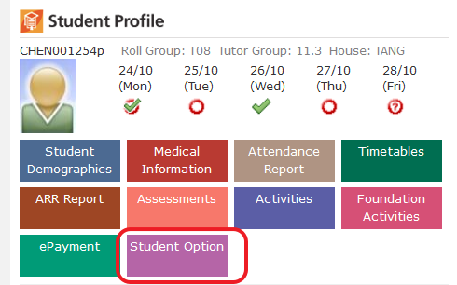
- It will open the option form for review:
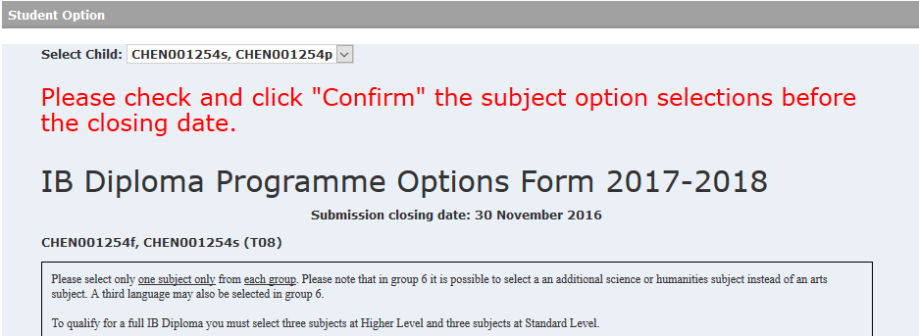
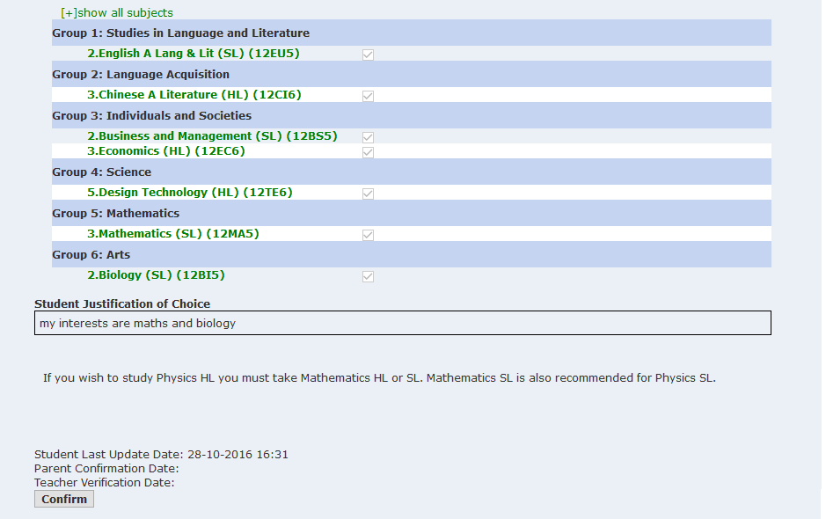
- You may click “[+]show all subjects” on the top of the list to open all subject options available for selection.

- Click Confirm, if successful, it will show the parent confirmation date at the bottom of the form.

