Parents and family members Working with Children Declaration

Parents may login Gateway (with PARENT account) to submit Working with Children Declaration on Gateway.
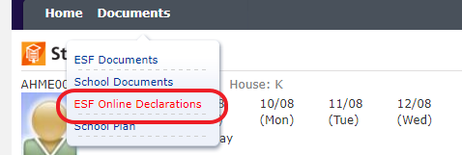 | Parents login Gateway  https://gateway.esf.edu.hk/  Select Documents >ESF Online Declarations  to open the function
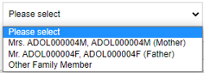  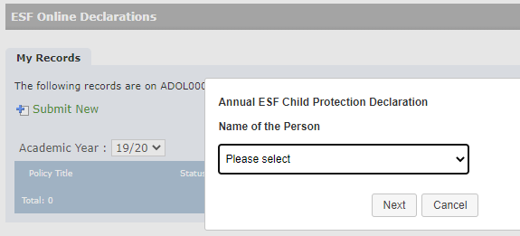 | Click on the link, a box will pop up for selecting the family member to submit declaration.  - If select the parent/guardian from the dropdown e.g. Mother, Father, it will open the Working with Children declaration form for submission.  - If both parents wish to be in school to be volunteers, please submit two declarations respectively.
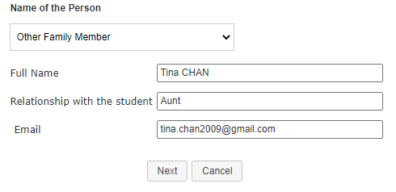 | If select “Other Family Member”, e.g. for grandma, aunt etc, it requires to fill in the details, i.e. full name, relationship and a valid personal Email address.  Click on the “Next” button, it will send an Email to the designated Email address with a magic link for submitting declaration without logging into Gateway.
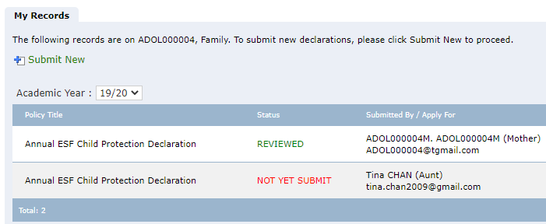 | You may see all declaration history for each academic year.

