Gateway Y7 Transfer Form – Parent User Guide
Parents may submit the Y7 Transfer Form once only. Please input the information and verify the data carefully before submitting. Login to the Gateway. Click on Home if you need to return to this page.
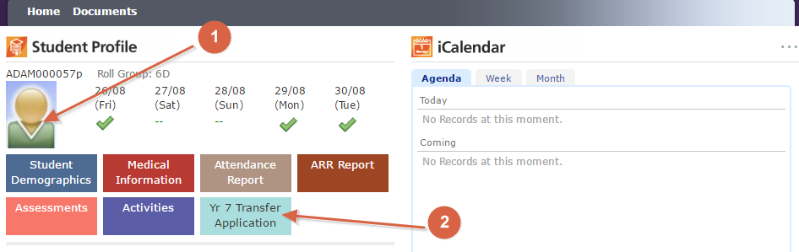
If you haven’t verified your child(ren) and family information for the current school year, you have to click all the Verify Now links to verify/update all the information, and click Complete button to finish the process before you can move on to the Home screen.
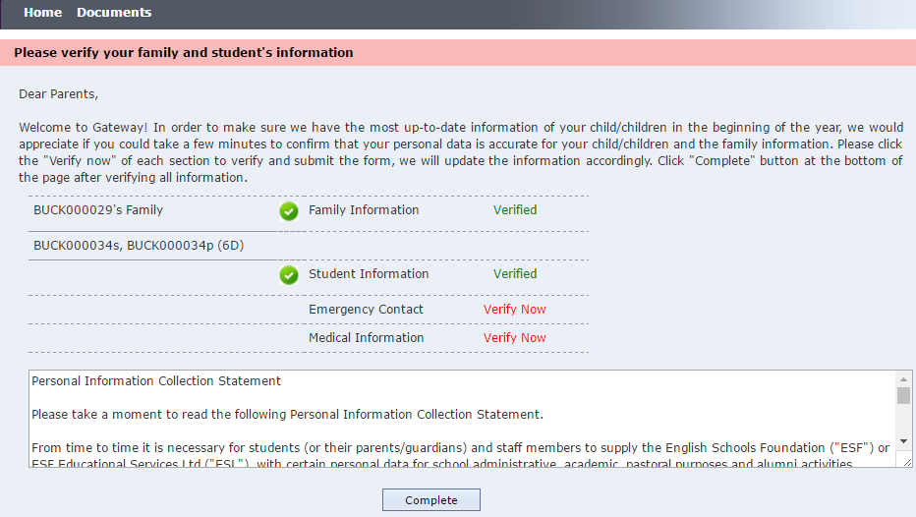
On the Home screen above:
- Select the Y6 student to show the colored buttons.
- Click on the “Yr 7 Transfer Application” to launch the form.
- Fill out the Transfer Application Form:
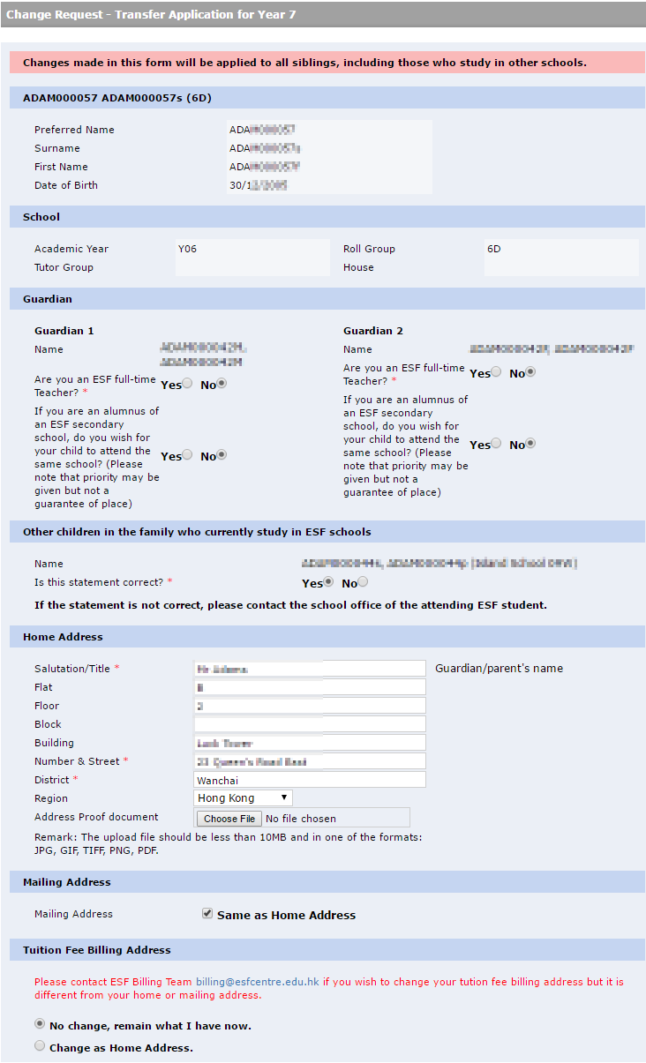
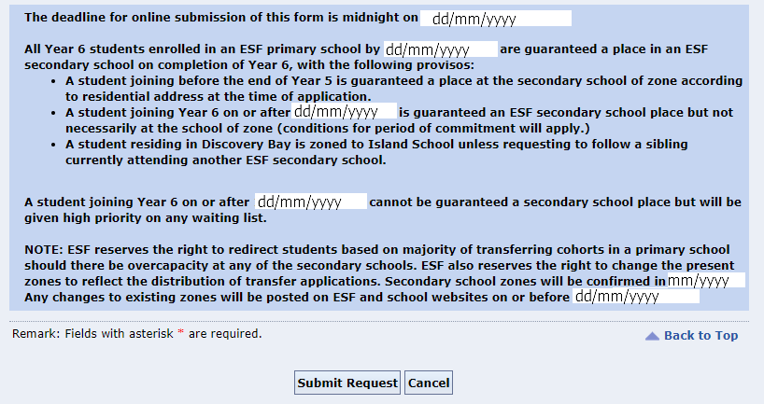
- Click Submit Request to continue
- Verify the contact information if there is any changes in previous screen
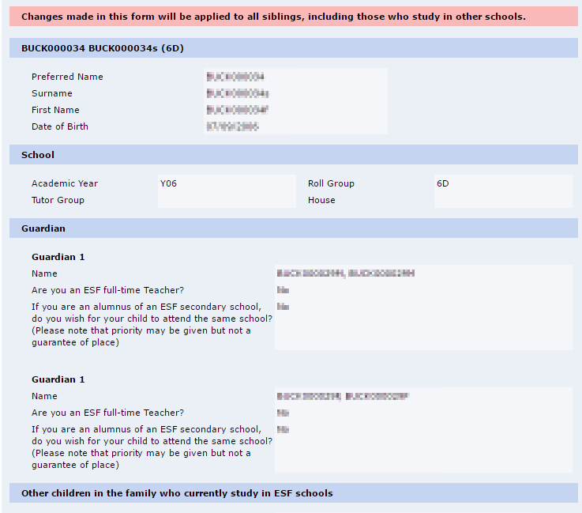
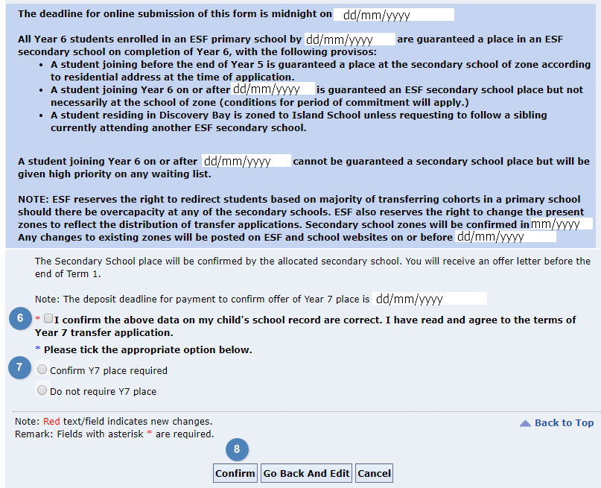
- Tick the checkbox to confirm the data is correct and you agree to the terms.
- Select the option Y7 place required or not.
- Click Confirm to complete the form. It will return to the home screen after successfully submitted.

You may submit the form once only. You may click the “Yr 7 Transfer Application” button on Home screen to view what you have submitted. Please contact the school if there is any problem with it.
- End of Document -

