Student Demographics, Medical Information

At the beginning of each school year, parents are requested to login Gateway, the system will enforce you to verify or update your children’s information.

During the year, if there is any changes to student information, parents may submit changes via Gateway, which include the following areas, this document only cover the first 4 areas below:
- Student Information
- Family Information
- Emergency Contact
- Medical Information
- Opt-in Communication (please refer to another document “Opt-in Communication” on Gateway support website)
- After-School Go Home Arrangement (please refer to another document “Update After-School Go Home Arrangement” on Gateway support website)

IMPORTANT NOTE
The update you make will not be effective immediately, it will be submitted to school and please wait for the data administrator to process your change request in a few days. It is very urgent and critical, e.g. urgent medical condition update which might affect your child’s activities, after submitting the change request form via Gateway please contact school office to process your change request immediately.

If you have technical problem with the system, please contact the School Gateway Support.

- Login the school Gateway website, on the home page you will see student profile section. Select a child if you have more than one in the school.
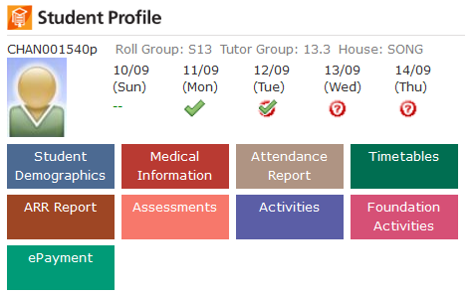
- Click on the colourful buttons will take you to different modules. The buttons that appear will depend on what modules are made available to parents by the school Gateway Manager.

Student Demographics

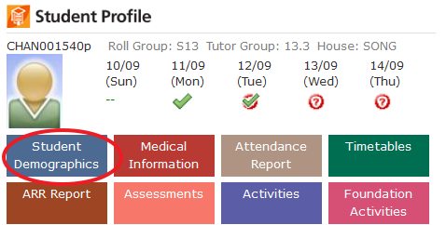

- You may find three tabs in Student Demographic: student information, family information and emergency contact.
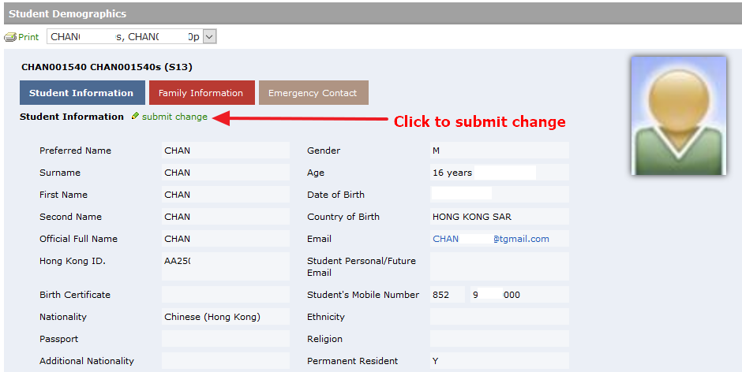

  - If you wish to make changes to the information in the selected tab, click on submit change link to launch the change request form > fill in the update > preview changes > confirm submit.
  - The update will not be effective immediately, it will be submitted to school and please wait for the data administrator to process your change request.

Medical information
  - It is very important to keep your child(ren)’s medical information update.
  - On Gateway homepage, click on the Medical Information button of the student to view the current medical data store in the system.

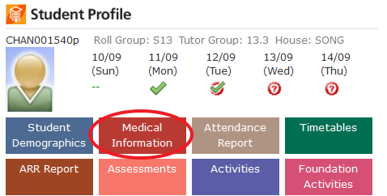
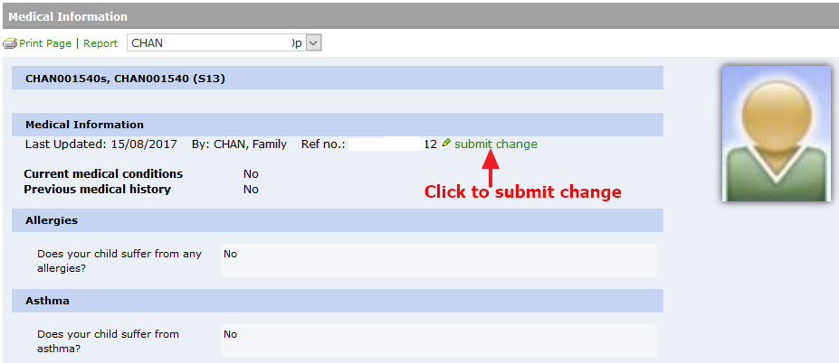
  - You may click on the submit change to launch the change form > fill in the update > preview changes > confirm submit.
  - The update will not be effective immediately, it will be submitted to school and please wait for the health professional staff to process your change request.

