Parent Consultation
School will notify parents about the schedule for parent consultation booking on Gateway. The booking process is online and is on a first-come-first-served basis. Parents may login to Gateway to make appointments within the open booking period. Please make sure you know your Gateway login to avoid problems. If you have not logged into Gateway this school year, please login early to complete the student and family data verification process, as this may take 5 minutes or more.
Login Gateway https://tg.esf.edu.hk
- Home Parent Consultation
- You may see the click to book or update link if any event is open for booking.
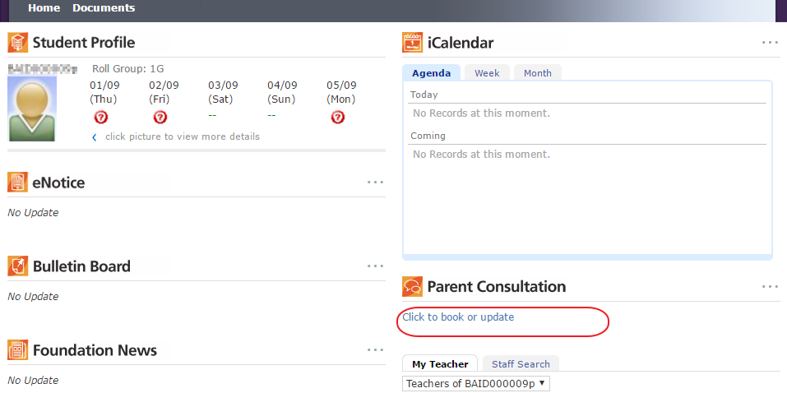
- Click on the link to launch the Parent Consultation module
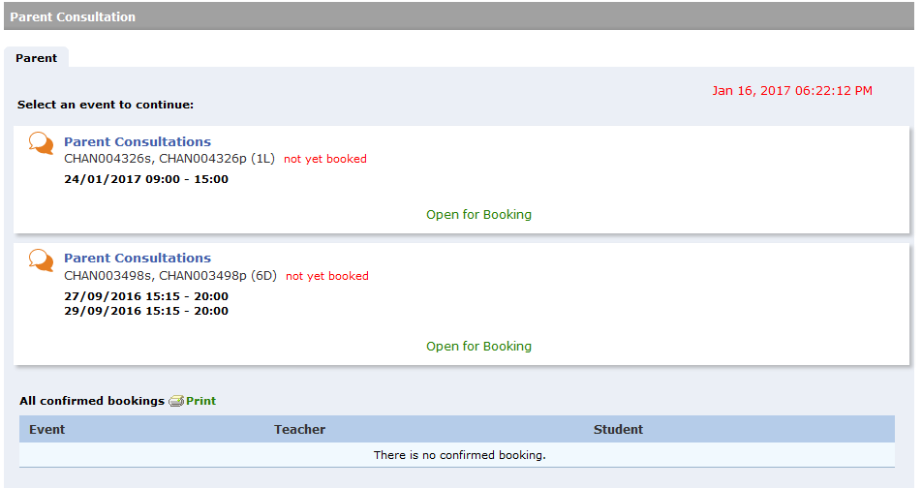
- If there are any, you will see event(s) with “Open for Booking” status, which allow you to book or change teacher appointments. If an event is closed or is view only, it will not allow you to go further to book or change appointments.

Make Bookings
- Click on an “Open for Booking” event to show the booking table.
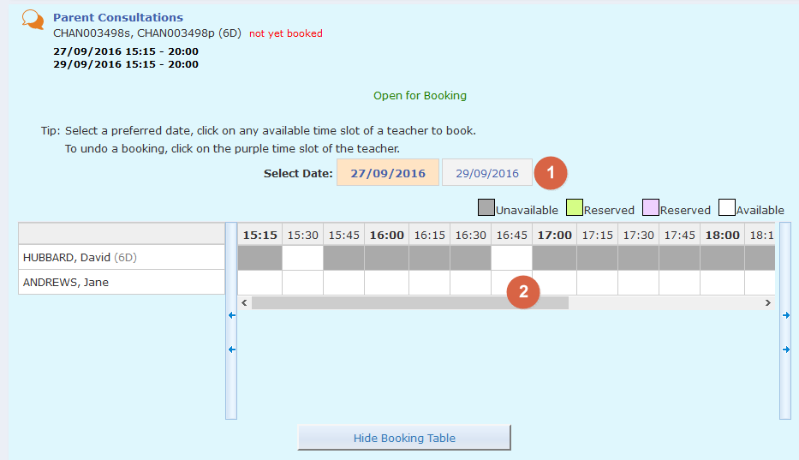
- Step 1, if the event has more than one date, you may select a preferred date for your booking(s).
- You may book one time slot for each teacher.
- The grey time slots indicate the teacher is unavailable, while the white time slots indicate the teacher is available for booking. You may change the date (if applicable) to view their availability.
- Step 2, click on the preferred white time slot of a teacher to book. It will change to purple, which indicates that the booking is confirmed, and will add a green tick next to the teacher’s name.
- If there is more than one teacher, you may repeat Steps 1 and 2 to book other teachers.
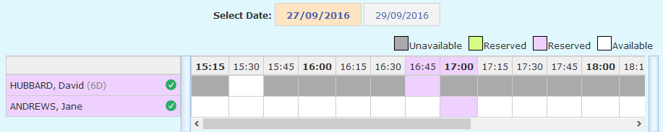
- At the bottom, you will see a list of confirmed bookings.
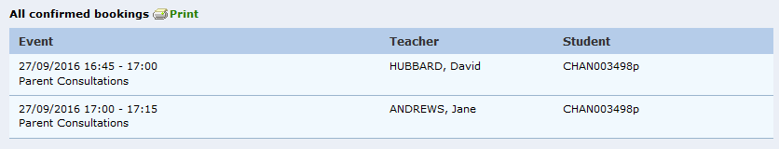
Please make sure to complete your bookings within the open period; no further booking/update is allowed once the booking is closed.

Cancel Bookings
Click on the booked teacher’s name (purple), or the purple time slot, and click on OK to confirm that you want to cancel the booking.
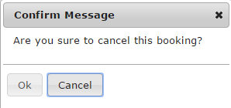

Change Bookings
You need to cancel the original booking slot first then click on another vacant slot.

View and Print Your Bookings
The Gateway homepage provides a quick view of the upcoming booking schedule, which will be removed a few days after the consultation event finishes. You may also open the Parent Consultation module, scroll down to the All confirmed bookings list to print the schedule.
