Opt in communication
- When some parents first login to the Gateway they decide to opt out of receiving information from school/ESF.
- If you then decide you do want to receive information you need to opt in.
- If you have opted out the home page will look something like this.

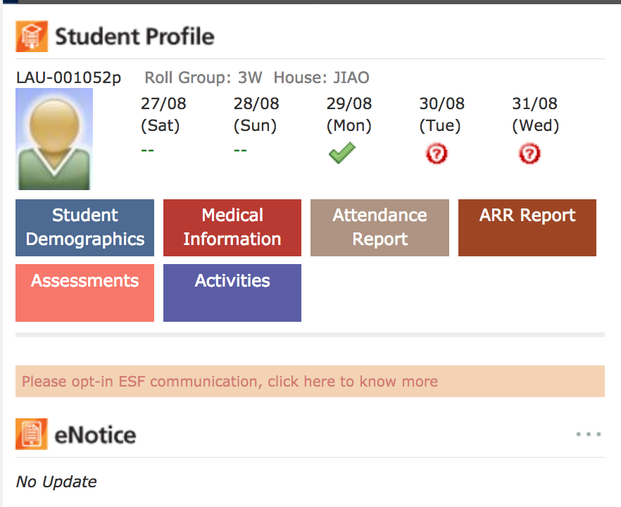
- Click where it says click here.
