ESF Foundation Activities Enrolment

Parent may enrol activities organised by ESF for their children, e.g. Beijing Trip for P6 students. To do so, parent login Gateway (with parent login account):
- On your homepage, click Foundation Activities under the student’s profile
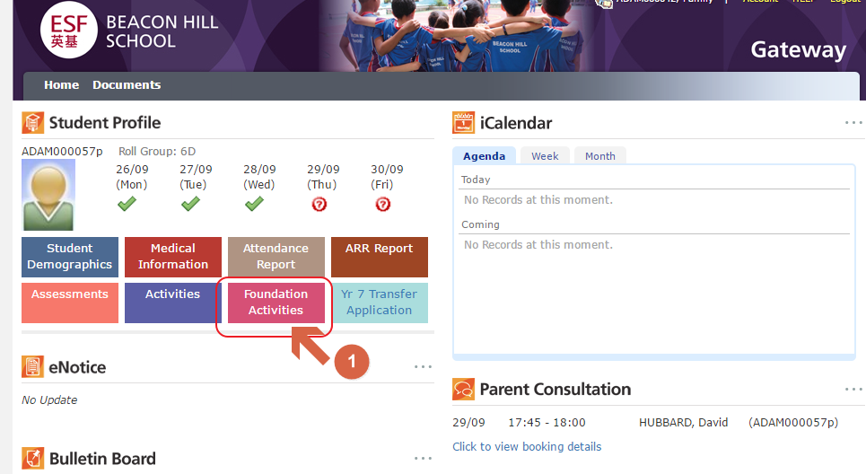
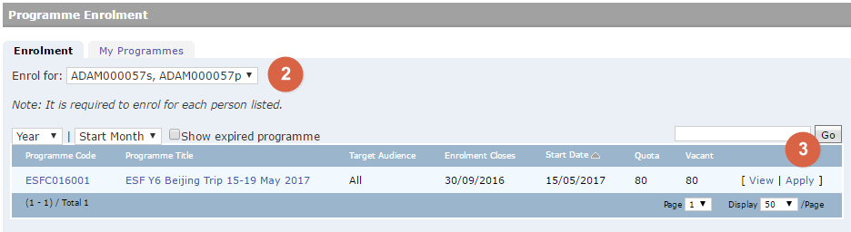
- Slelect the student name, you will see the activity list (if available) for the selected student. You may click the Programme Title to view details about the activity.
- Click Apply to open the enrolment form below, fill in all required details and click Submit to enrol.
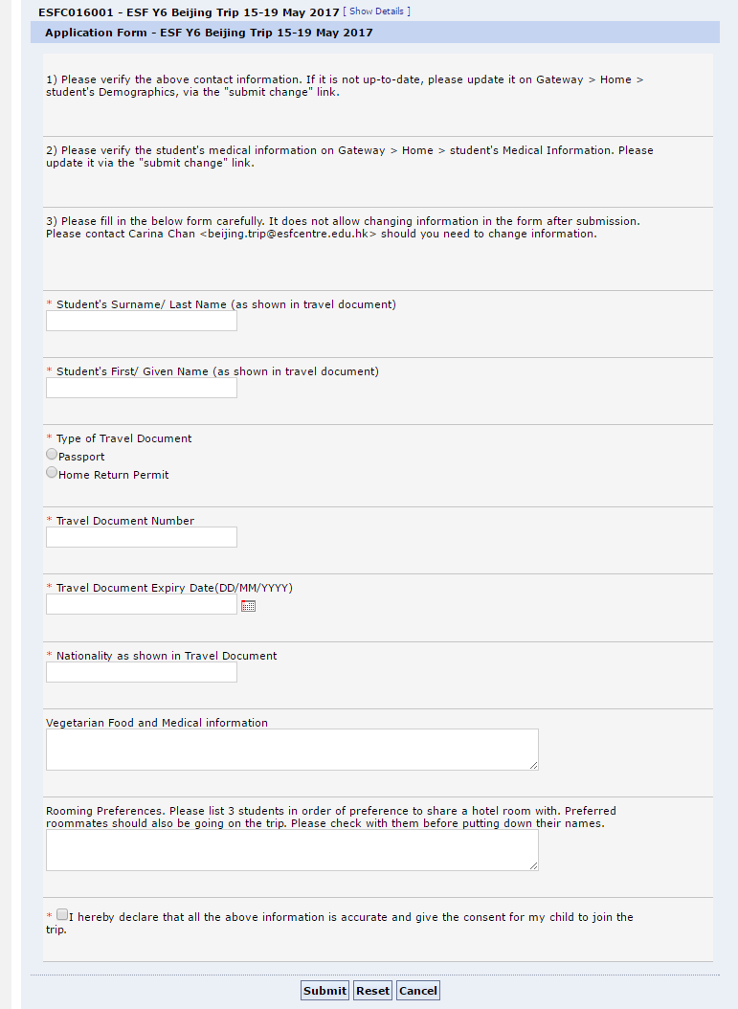

Change information on enrolment form, withdraw enrolment

Parent may login Gateway to change information or withdraw enrolment online in 80 days prior to the activity start date. Please refer to the steps below. Any change/withdraw will need to contact the Contact Person of the programme. You may find the email address on the programme details.
Open the Foundation Activities module on Gateway (refer to the first screenshot).
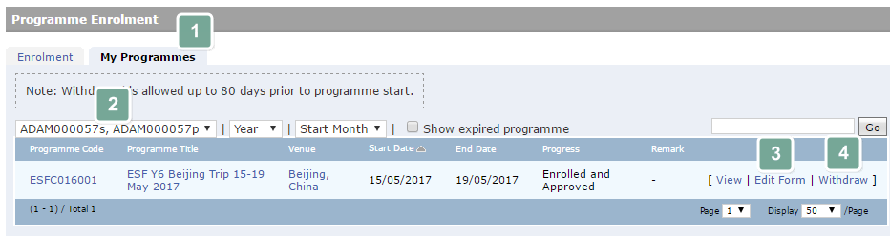
- Select My Programme.
- Select your child’s name.
- To change information, click Edit Form.
- To Withdraw the enrolment, click Withdraw.

