eVoting
School will notify parents about the schedule of online voting, e.g. for school Council Chair Person election.
Login Gateway https://tg.esf.edu.hk
- If the voting campaign available, you may see the eVoting at the first section of the Gateway homepage, there will be a link CLICK HERE to vote.
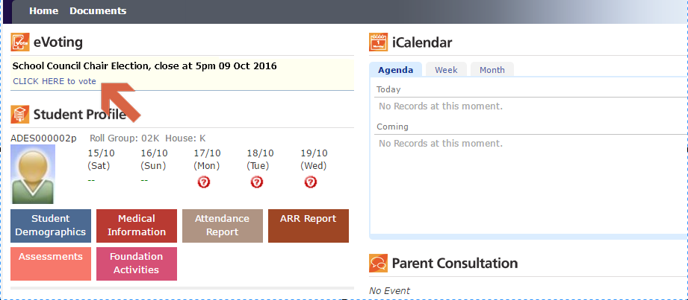

- Click on the link to open the eVoting system
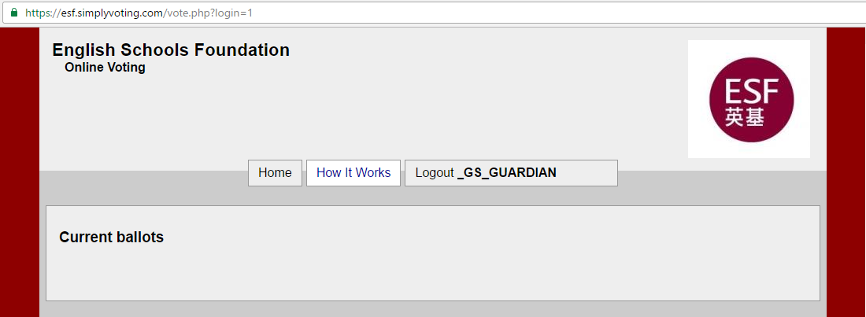
- Just follow the instruction to complete the voting

