ePayment
- At some schools parents may make payments through the Gateway using the ePayment module.
- The ePayment module requires you to pay some money into the system to give yourself credit and then payments will be deducted from your account.

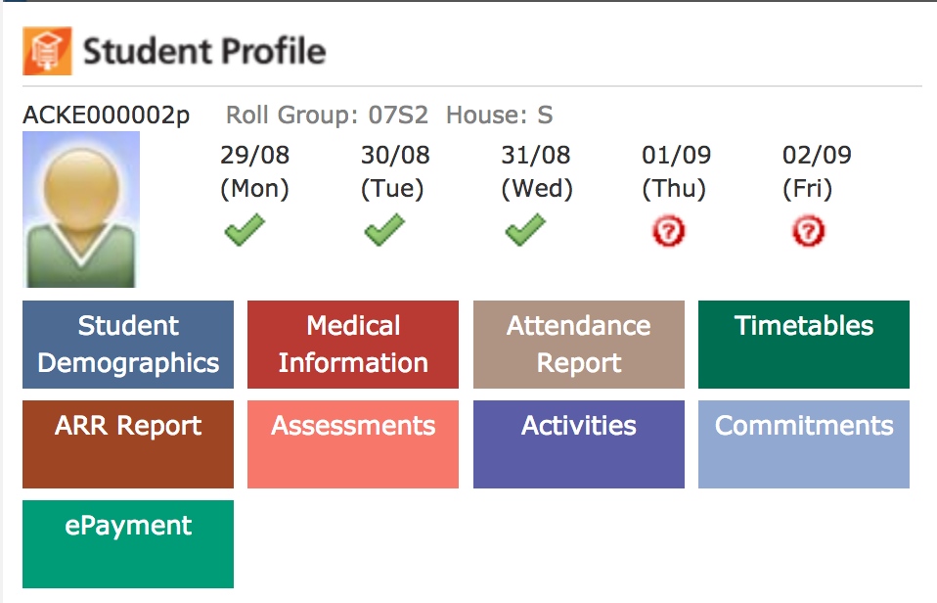
- Once selected you will see a number of tabs.

Payment records
  - View a list of all payments made on behalf of the selected student.
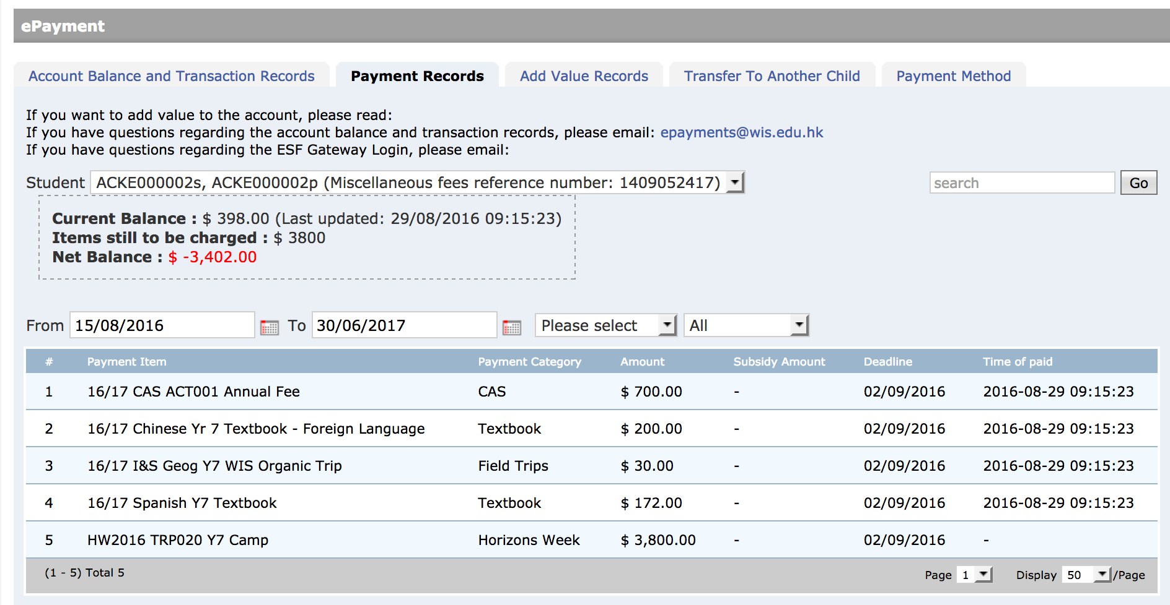

Account balance and transaction records
  - See payments and the current state of your account.
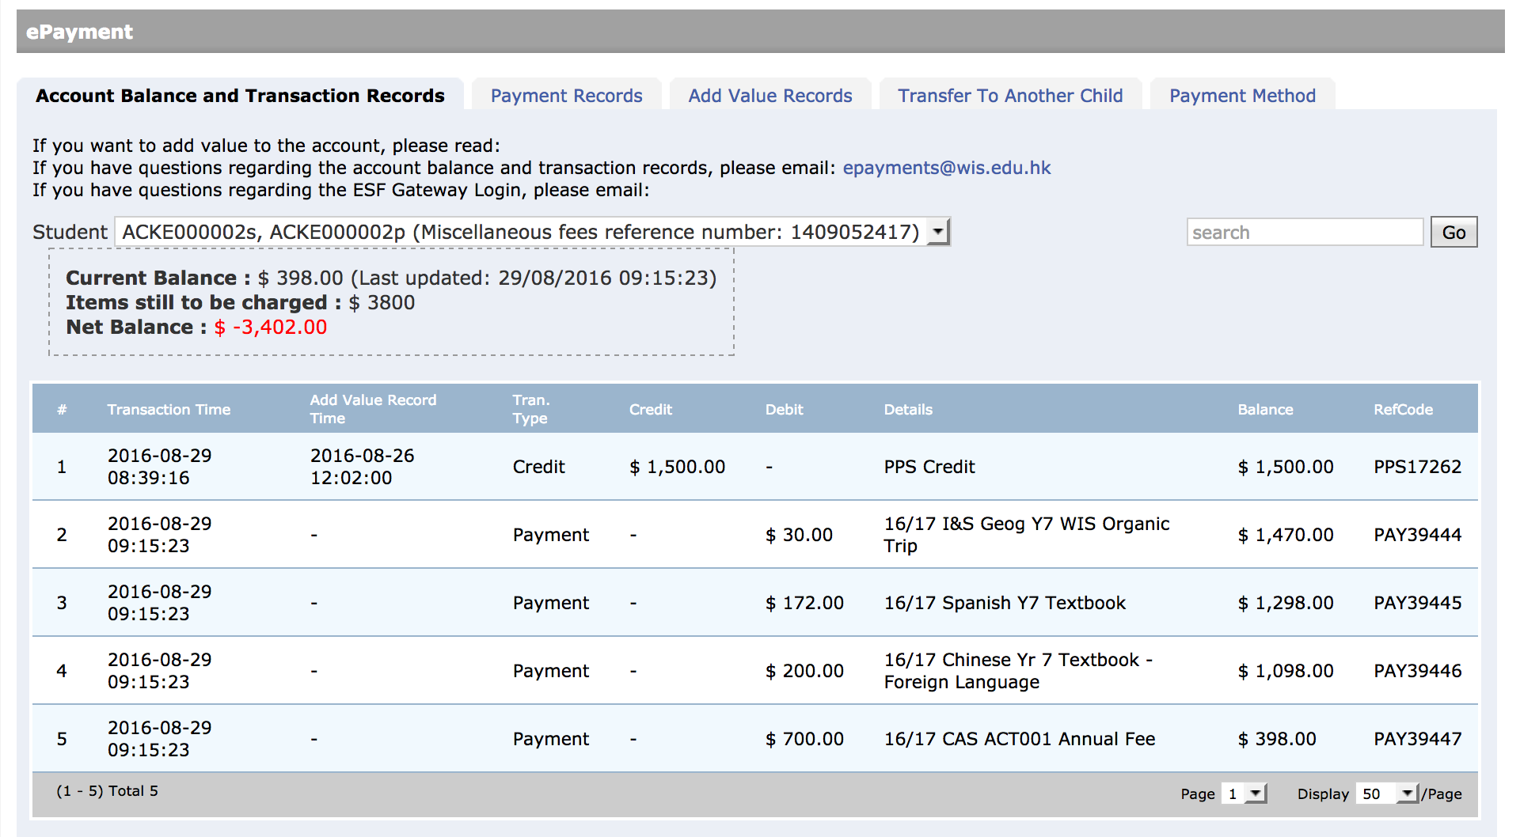

Add value records
  - View records of payments into your account.
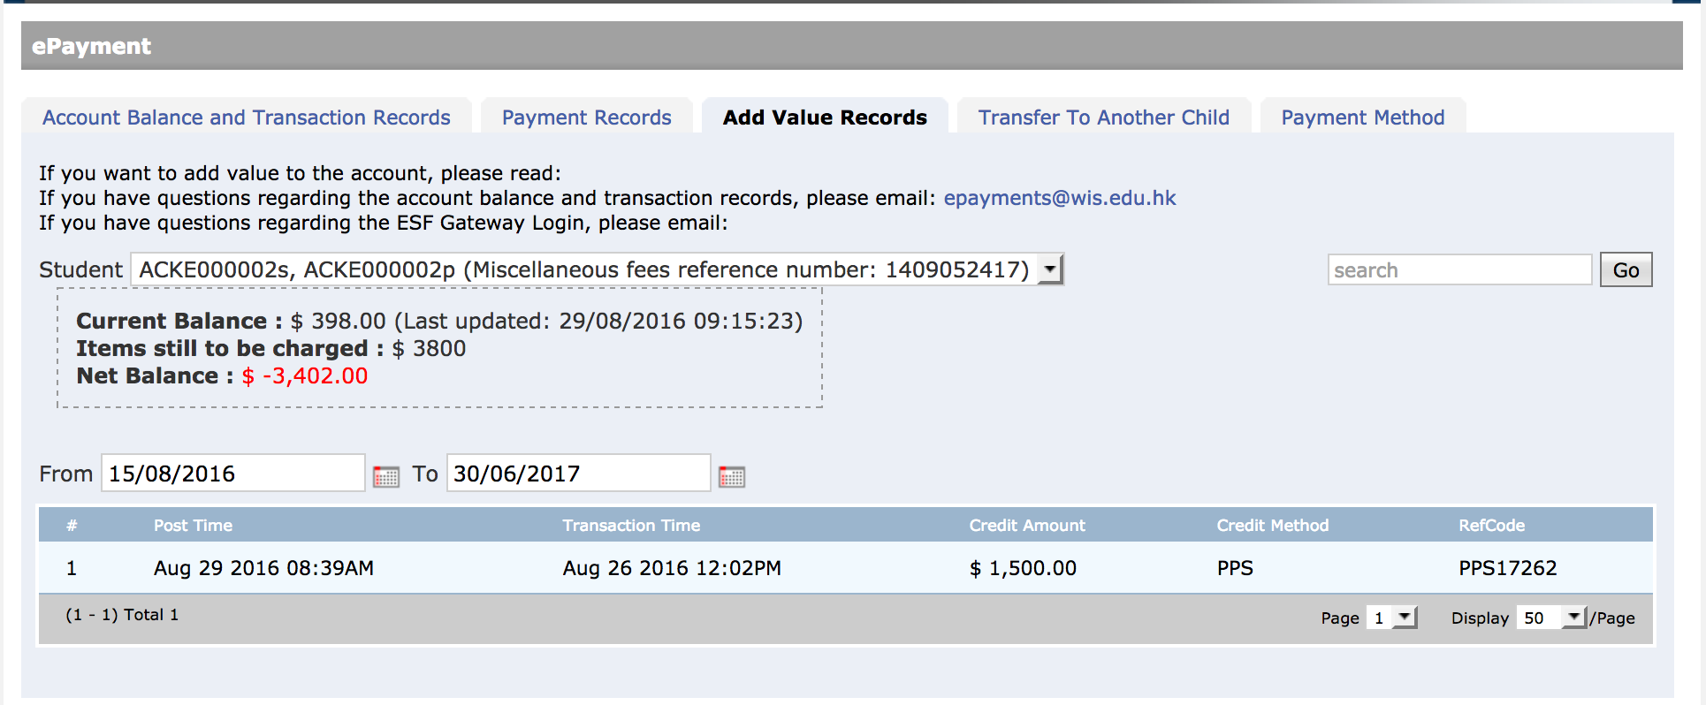

Transfer to another child
  - If you have more than one child at the school and there is more money in your account for one child, you may transfer funds to another child.

Payment method
  - This page may give you more information regarding the use of the ePayment system at your school, either with a link to a more detailed document…
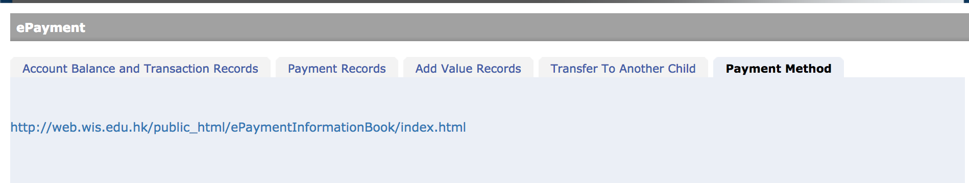
….or with information on the page.
