Notices
- Whenever you login and go to the home page you may see a message box.
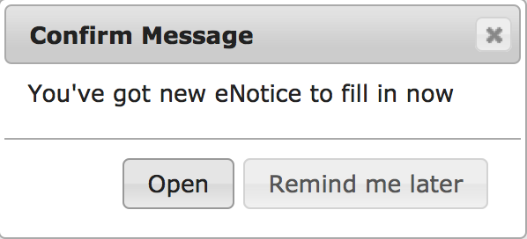
- You can open the message and complete the form immediately or leave it until later.
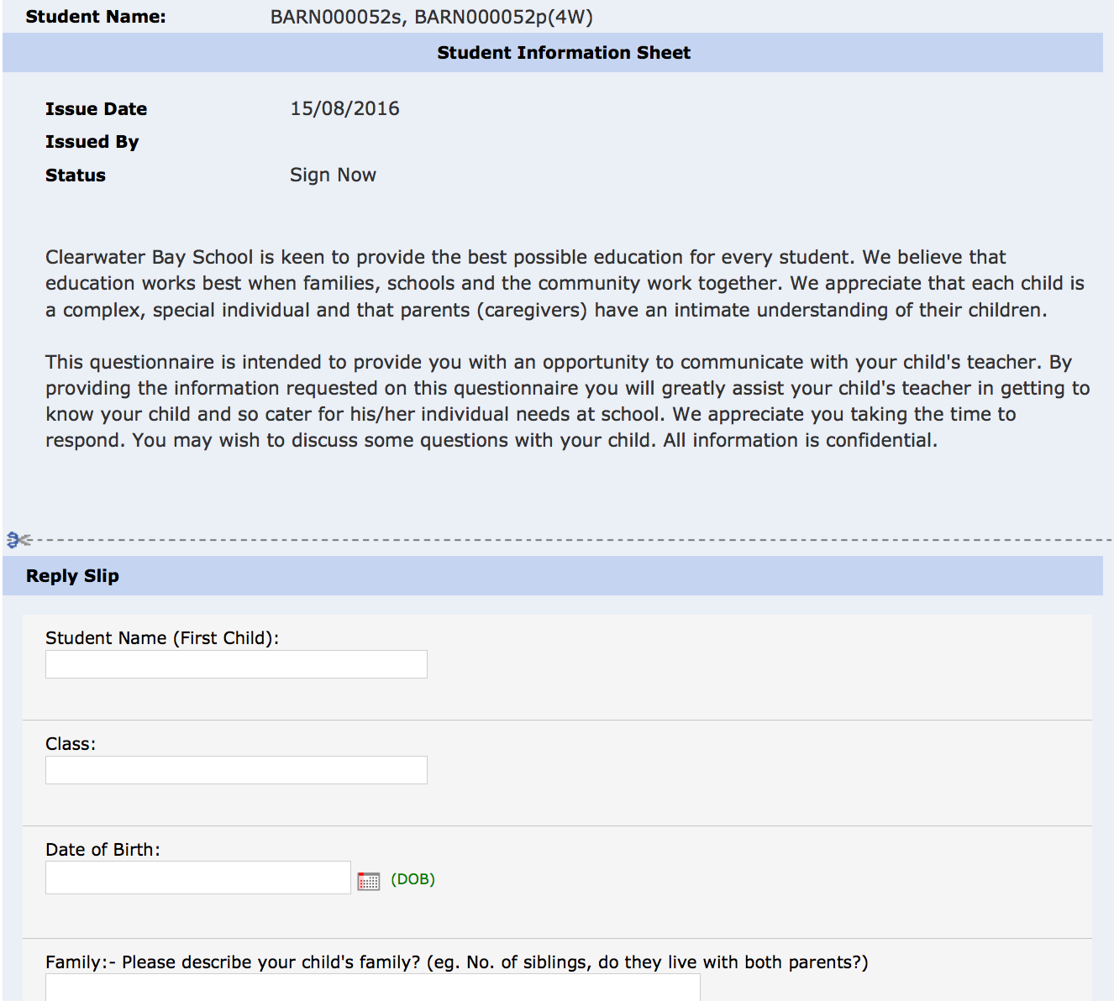

Links
- Look at the top right of the page.
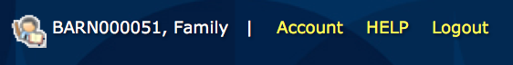

Account
  - Click on account to change your password.

Help
  - Click on help to go to the parent hep page.

Logout
  - Click on logout to finish using the Gateway.

eNotice
- As mentioned earlier, when you login you will be informed of any eNotices that require your attention.
- In the eNotices section on the home page you will see a list of any eNotices that require attention.
- Click on eNotice to see all the eNotices that you have received and their status.
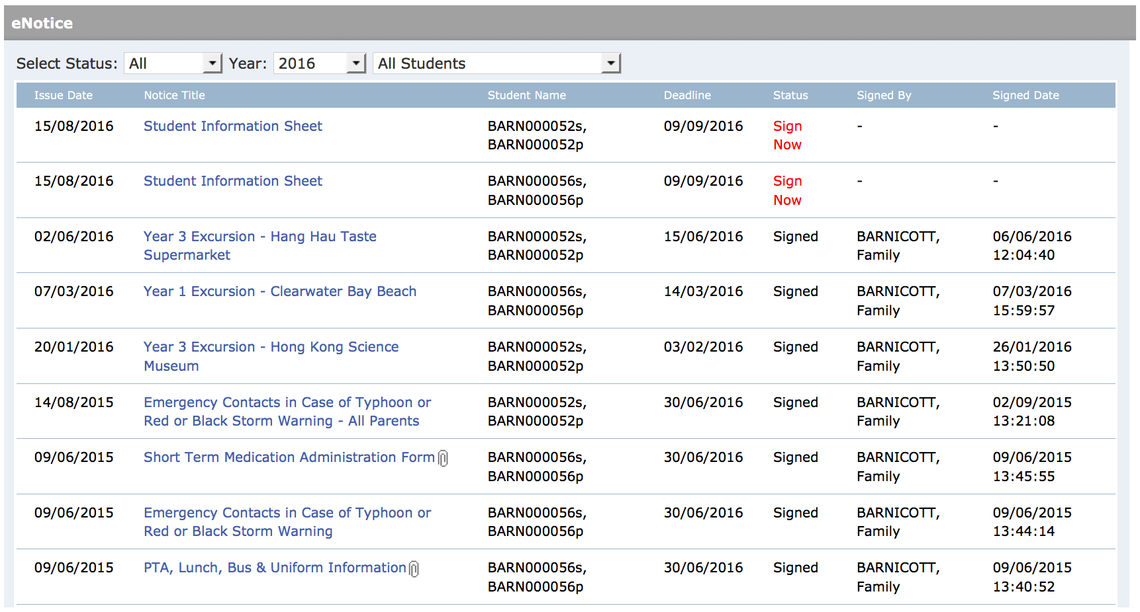
- Click on the title of the notice to read and/or sign it.

Bulletin board
- The bulletin board may be used by the school to post the latest information for parents.
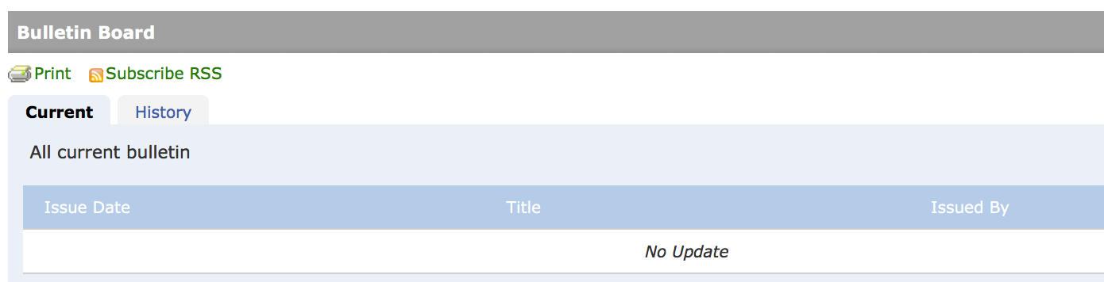

Foundation news
- Similar to the bulletin boards this area will show notices issued from ESF rather than the school.
