Navigation
- At the top of the page you will see the navigation bar.
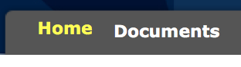

Home
  - Click on home.
  - Most of what you need should be found on this page.
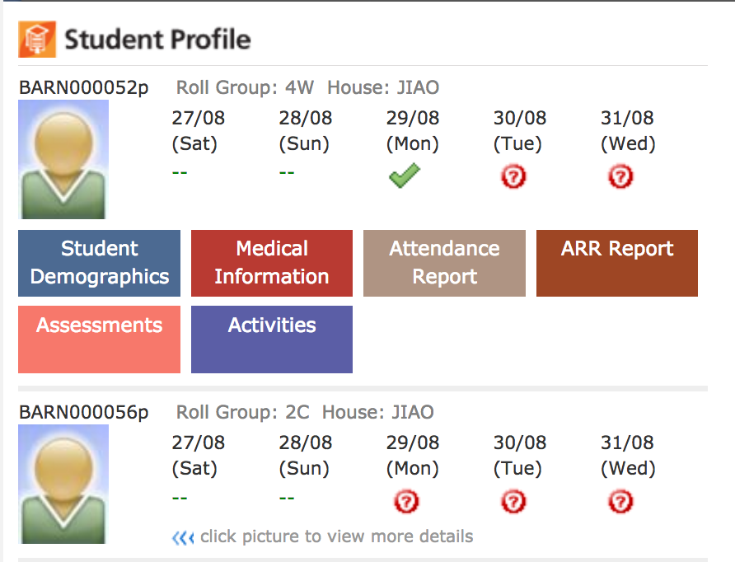

Documents
  - Click on documents.
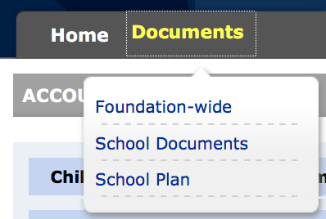
  - This will give you access to documents from the school or from ESF.
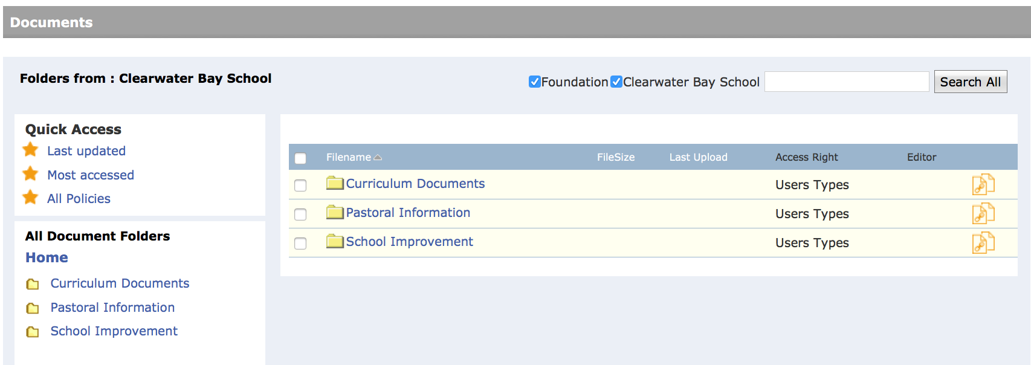
  - Click on the document name to download.

