View ARR Report
ARR stands for Assessment Recording and Reporting. Teachers write the assessment and report for students and publish it on Gateway and viewable by parents/students.
Login Gateway https://tg.esf.edu.hk

PDF report
Home Student Profile ARR Report
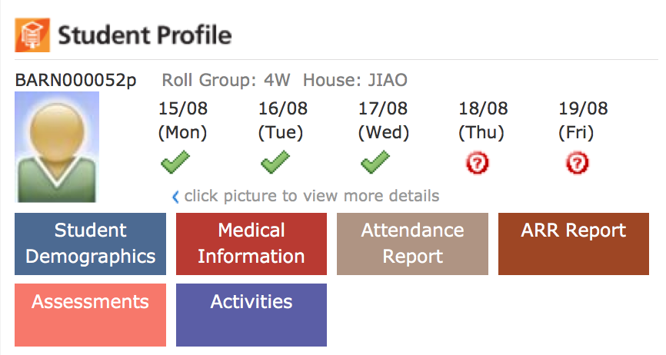
- Click on ARR report to access all your child’s reports. You will notice the tab at the top says PDF report.
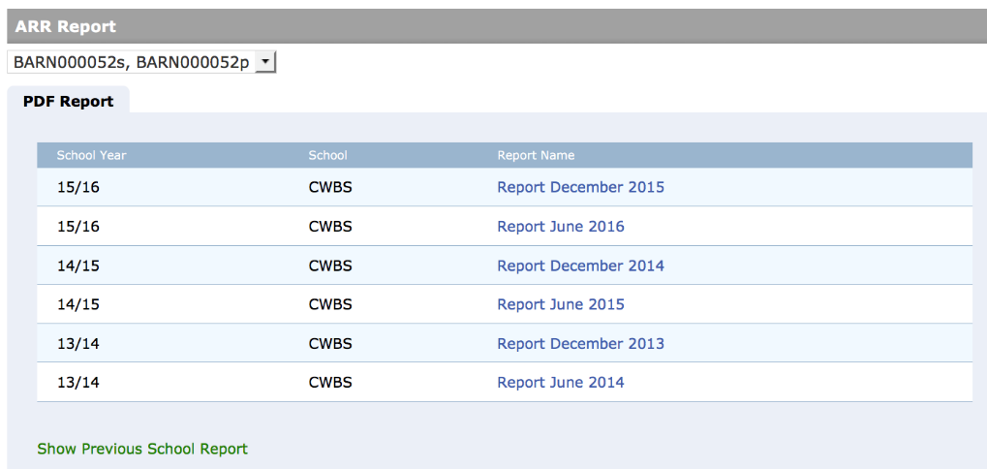
- Click on the name of the report to download it.

Online report
- Some schools may give access to an online report which is an ongoing report that may be viewed on the website. If the tab is available, click on it.
- This will show a list of subjects. Click on view for more detail.
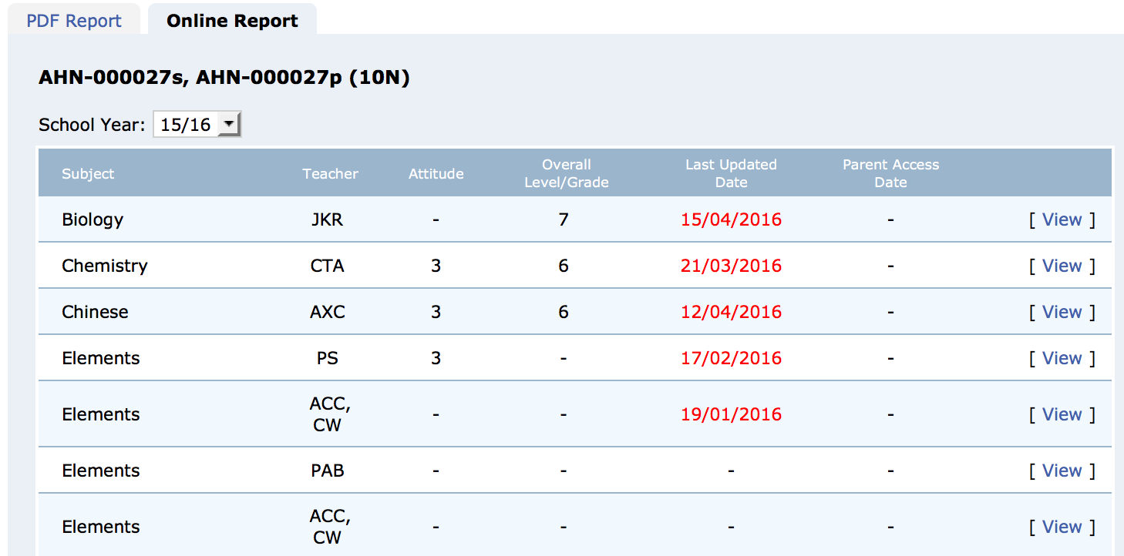

Assessments

Schools run a number of external tests. Results of these may be made available to parents. Click on assessments to view them.
You will see the assessments result if available.
