After school management
- After school management is used by some schools to keep track of how students travel home from school.
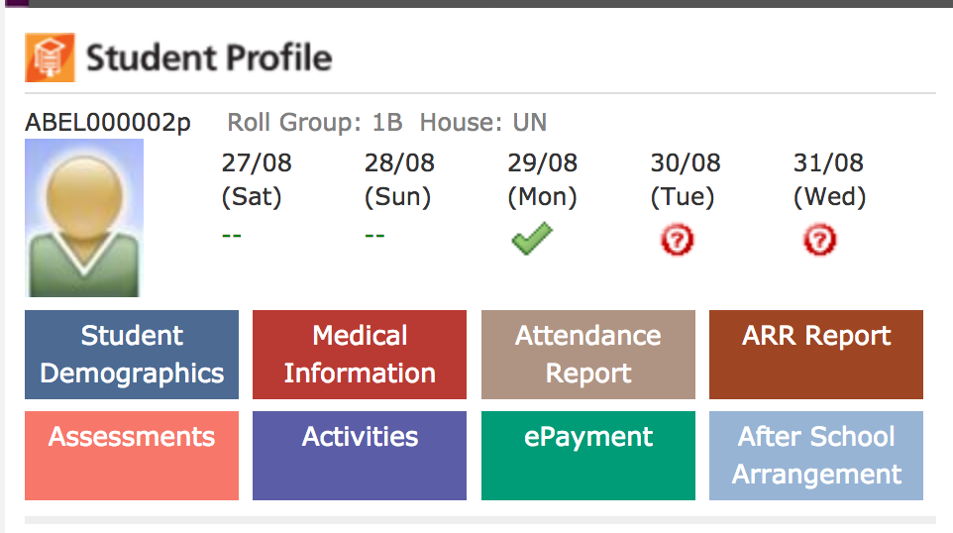
- Click on after school management. You will see information that the school has about your child.
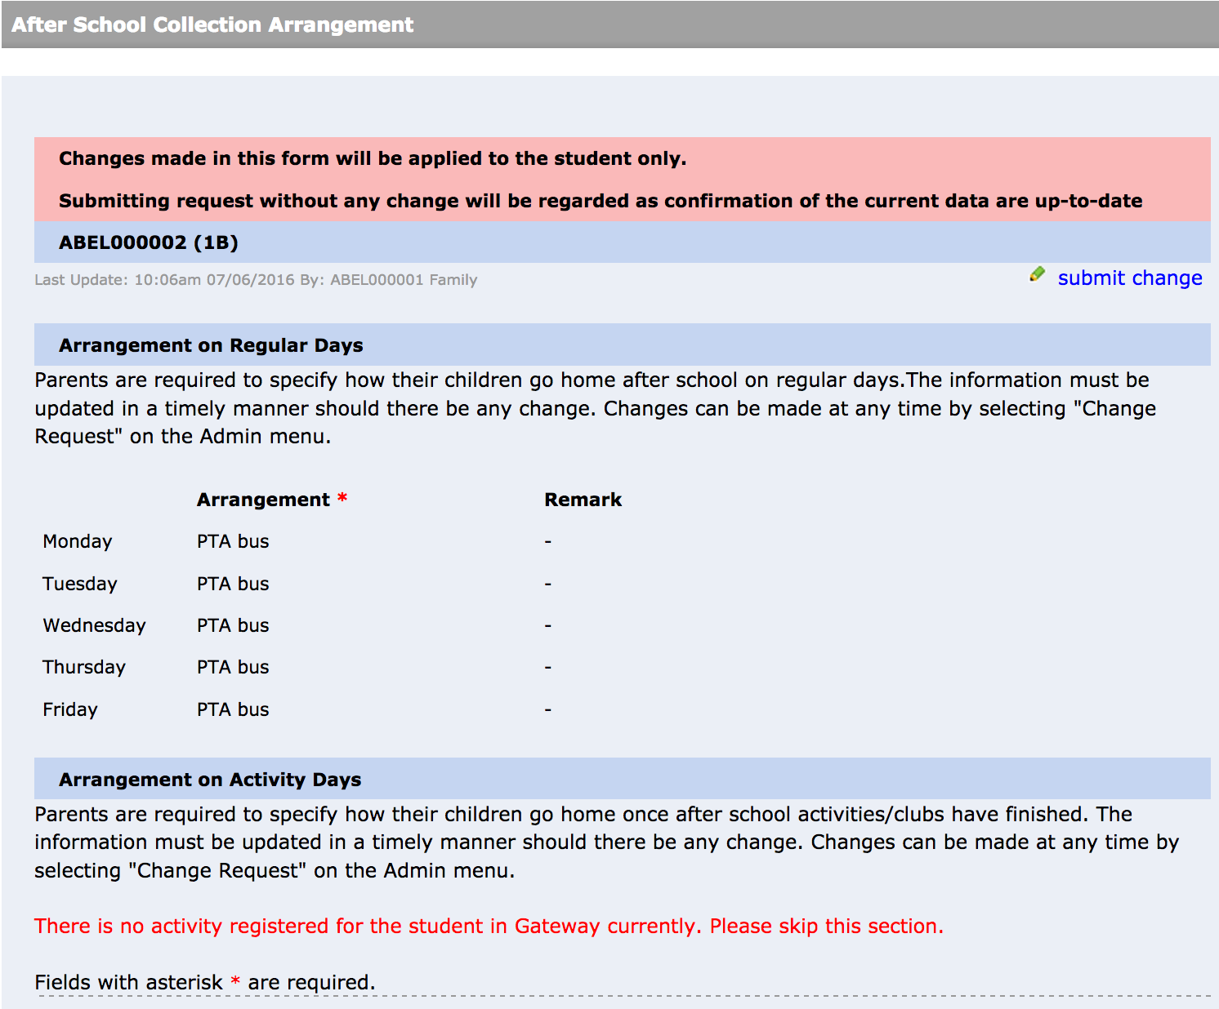
- To make changes click on submit change.
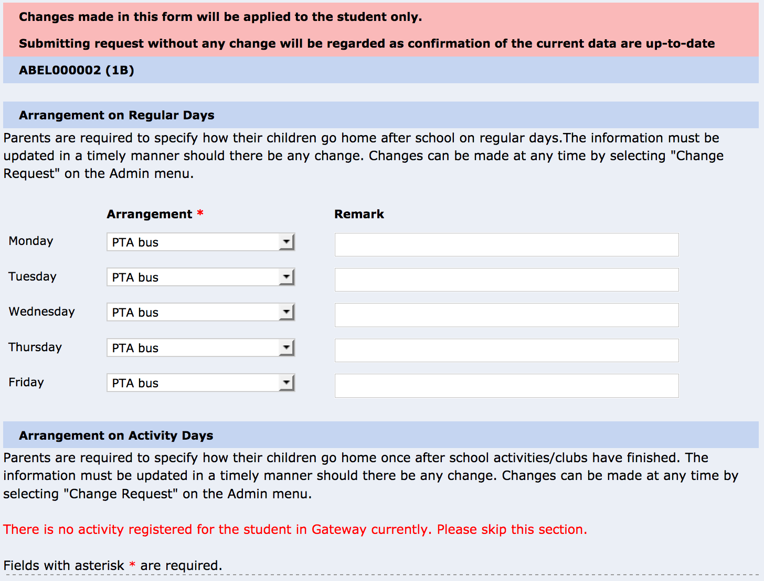
- Enter any changes you wish to make then click on submit at the bottom of the page.

