Activities
Some schools will allow sign up for activities through the Gateway. Parents may sign up activities for their children, or for themselves. Students with Gateway login may also sign up for themselves.
Login Gateway https://tg.esf.edu.hk
Click the Activities button of the student on Gateway homepage:
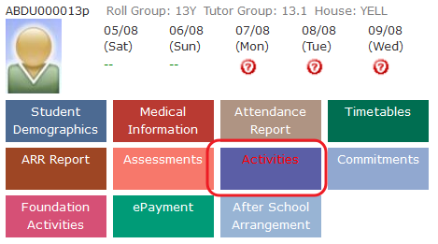

Register Activity
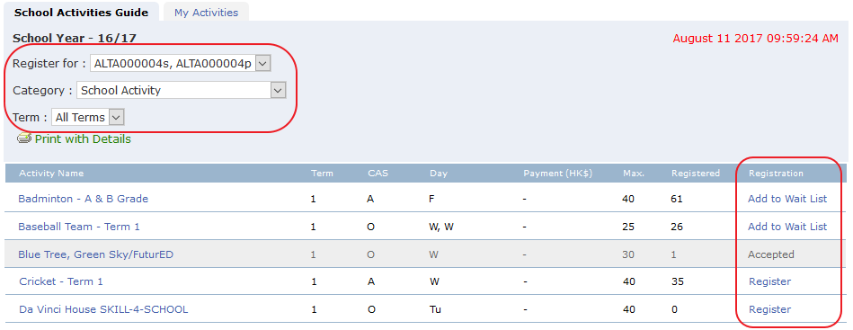
- In the School Activities Guide screen
- Select Register for (for parents login, select your child’s name)
- Select Category & Term to filter the activities
- Click on the Activity Name on the list to view more details
- Click on Register to register for activities. There may be limit on number of activities you can choose. Some activities are first come first sever while some might need approval.
- If the quota is full and it allows wait list, you may click on the Add to wait List to add yourself to the wait list. Then you may enroll until someone drop out.

View My Activities
To view what activities has been registered and the enrolment status
- Click on My Activities tab
- It will list all the registered activities of current school year with Status. Student or parent may keep track the enrollment status here.
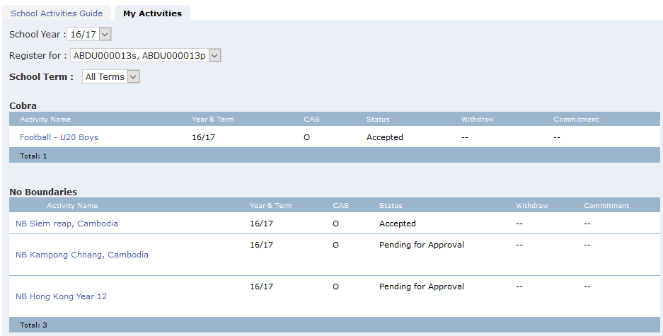

Set Preference Order
If preference order is allowed, in the My Activities screen you may set preference order by clicking on the arrow keys to move activities up and down.
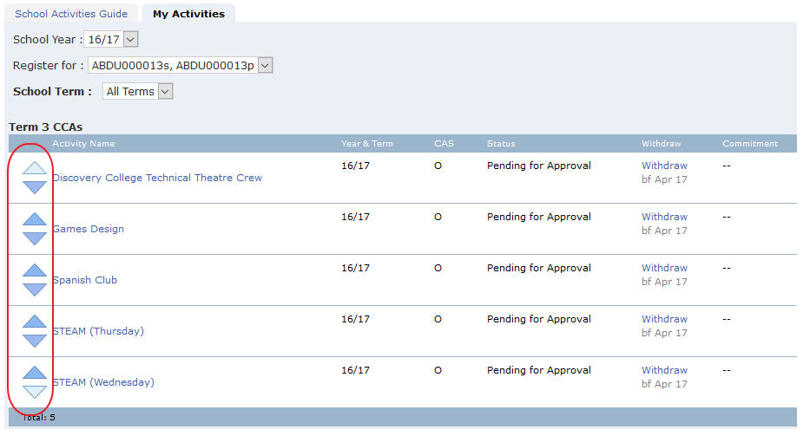

Withdraw activities
If withdraw activities is allowed, there will be a Withdraw link for withdrawal, and also indicates the date when user may withdraw before it. If withdraw is not allowed, the link will not be shown.
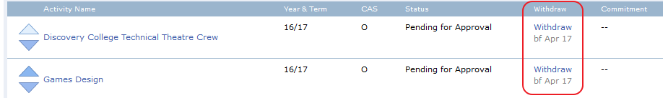

End of Document

