Gateway New Parent Account Activation and First Login

New parents will receive the Gateway Login Activation email when the school creates the account. The activation is a one-off, once activated, parents may login via the normal login page https://tg.esf.edu.hk .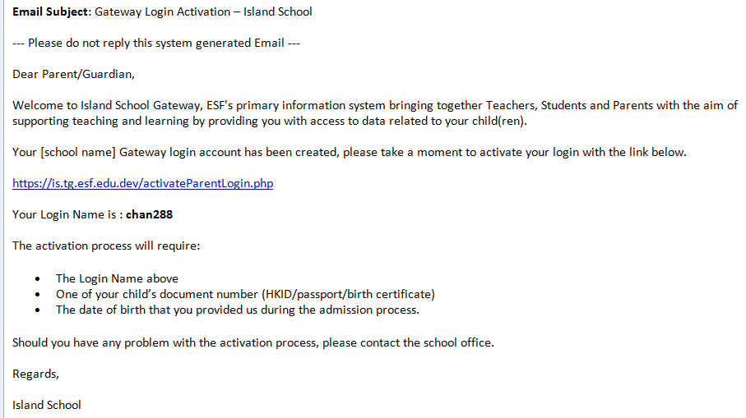
Click on the link in the email to open the Activate your account screen
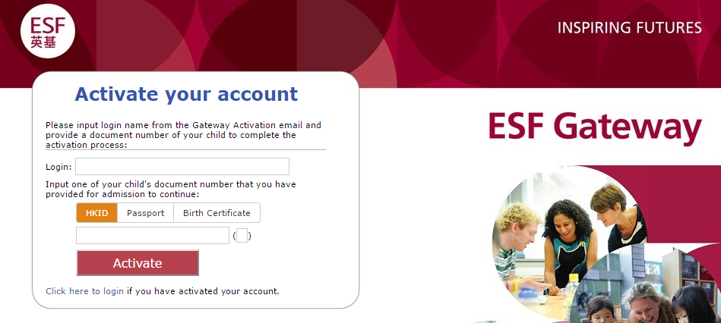
- Input the Login name provided in the email.
- Input the document number for your child (or one of your children if you have more than one at the school). Use HKID/passport/birth certificate, whichever you have registered with ESF.
- Click Activate to continue. If the account is activated successfully, it will move on to the next screen.
- If you have tried all document number and failed, please contact the School Office.

- Verify DOB
Input the student’s date of birth and tick Confirm this is my child
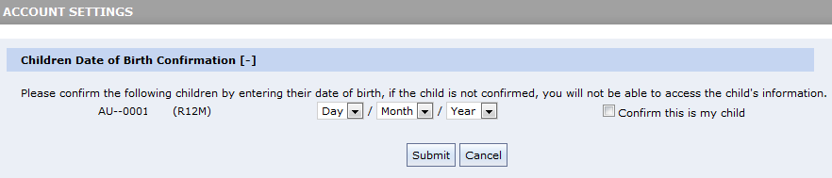

- Set initial password
Setup your preferred login password, it must be 6 digits or longer
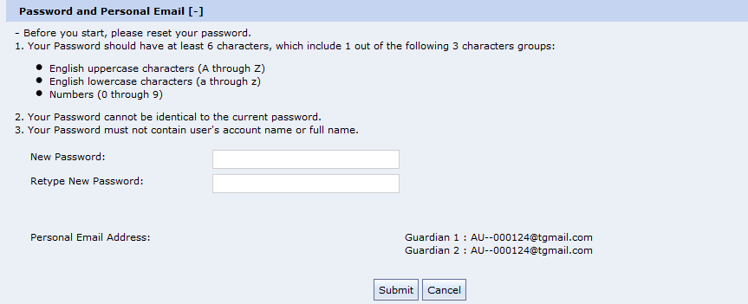

- Verify family and student information
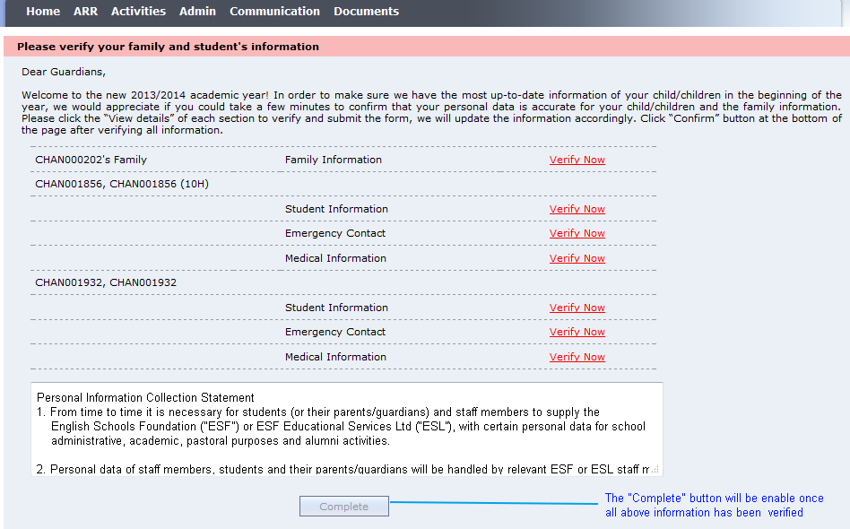
Please verify all the personal information by clicking on the Verify Now links one by one. Click Complete to finish the verification process.
- Opt-in Communication
Please opt-in to receive communications from us
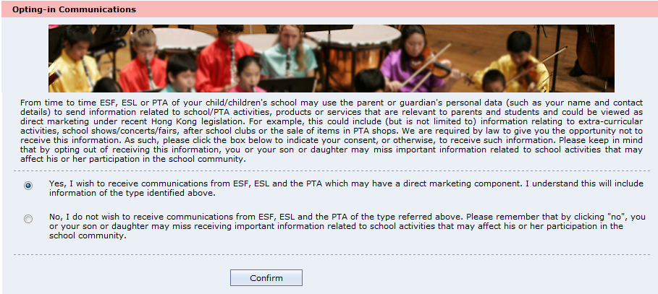

- Information Pack
If school requires parent to verify student information in this stage, you may find the Information Pack screen to continue. Please click “Sign Now” for each item to input and verify the information. Below is a sample screenshot only, you school might have different setup.
